Computer Science

**Purchase Verification Form**

## **PURCHASER: Please complete the information below and attach receipt(s), or send the completed form via email along with a detailed description of your purchase request.**

1. Provide a detailed description of items purchased/to be purchased:

1. Provide the detailed business purpose of the purchase (“to support research/teaching” is not detailed enough):

The ordered parts will be used in a skill development PCB for RoboSub.

## Funding Source(s) to be charged, include name and/or speedtype:

11002242 EEF Correll Robosub

**For the purchases listed above, I certify that the transactions were all purchases for University of Colorado business and that no personal purchases were made. For sponsored project purchases, I also verify that the Cost is reasonable, allocable to the project, and treated consistently, that the item(s) will be used only for the project listed and that the cost is explicitly listed in the approved budget.**

**November 17, 2014**

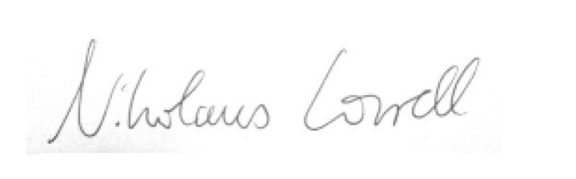

**Signature Date**

For sponsored projects, if you are not the Principal Investigator and cannot attest to the above statement, please ask the Principal Investigator of the project to do so.